Project Information
Date |  | Project name
Location |  | Total area |  | m²
Client |  | Contractor
Contact person |  | Phone no.
BarChip contact |  | Phone no.
Sales area |  | Due by date

System Information
Designated slab thickness |  |  | mm
Concrete class | C (EC2) |  | MPa
Max. joint spacing | × (saw-cut or expansion joints) |  | m
Max. pour field size | (within expansion joints) |  | m²
Type of construction | jointless | with control joints (saw-cut)
Separation layer (PE sheet) | single | double (cross-over) | none
Exposure | external | indoor (encased and covered)
Temperature difference | (indoor/outdoor at access portals) |  | ºC
Designated reinforcement | Type | Steel area | mm²/m
Notes/annotations

Pile Supported Suspended Slabs
Effective pile diameter |  | m
Pile spacing c/c |  | m
Pile cap dimension b × w × h | × × | m
Notes/annotations

Conversions: 1 MPa = 1 N/mm² 1 metric tonne = approx. 10 kN 1 bar = approx. 0.1 MPa

Ground Conditions
Please specify the ground conditions by either one of the three options below.
Winkler modulus | K |  | N/mm³ | bar/cm
Subgrade modulus | E_{V2} |  | MPa | bar
California Bearing Ratio | CBR |  | %
Notes/annotations

- Loadings
  - Uniformly Distributed Load
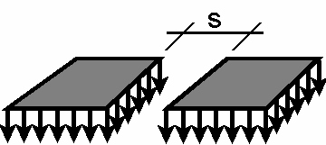 | Load |  | kN/m² | kg/m²
 | Aisle width s |  |  | mm
 | Partial load safety factor
Notes/annotations
If the aisle width is unknown, the design will be based on the critical aisle width.

  - Line Load
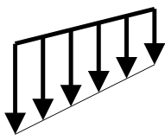 | Load |  | kN/m | kg/m
 | Partial load safety factor
Notes/annotations

  - Concentrated Single Load(s)
Here you can specify other single loads, e.g. columns of a mezzanine.
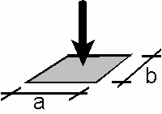 | Load |  | kN | kg
 | Dimensions a × b | × |  | mm
 | Distance to neighbour loads |  |  | mm
 | Partial load safety factor
Notes/annotations
  - Rack System
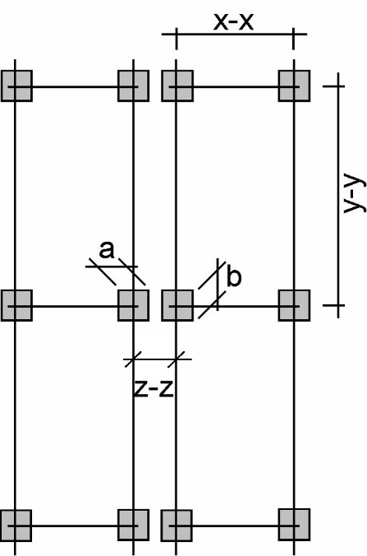 | Maximum foot load |  | kN | kg
 | Foot plate dimensions a × b | × |  | mm
 | Distances | x-x |  | mm
 | Distances | y-y |  | mm
 | Distances | z-z |  | mm
 | Partial load safety factor
Notes/annotations

  - Forklift
If applicable, it is sufficient to specify the forklift class in row 1 for standardized fork lifts according to EUROCODE 1, table 6.5.

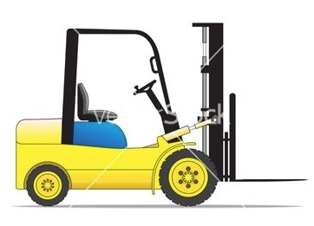  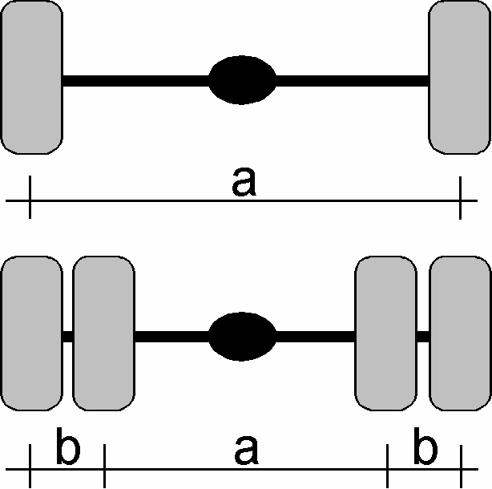 | Forklift class | FL (FL 1 thru FL 6)
 | Total weight |  | kN | kg
 | Front axle load |  | kN | kg
 | Rear axle load |  | kN | kg
 | Axle spacing |  |  | mm
 | Wheels per axle | 2 | 4 | (ruling axle)
 | Wheel spacing | a |  | mm
 | Wheel spacing | b |  | mm
 | Wheel contact area | × |  | mm
 | Wheel contact pressure |  | MPa | bar
 | Partial load safety factor
Notes/annotations

  - Truck
If applicable, it is sufficient to specify the truck type in row 1 for standardized trucks according to
DIN 1072.

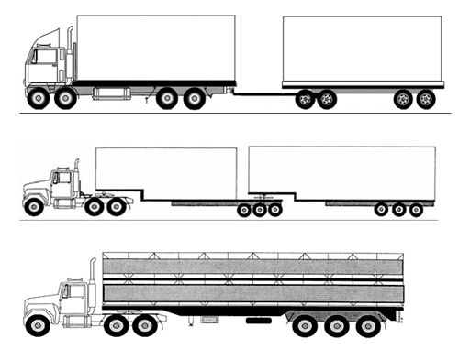 | Vehicle type | LKW |  | SLW
 | Total weight |  | kN | kg
 | Maximum axle load |  | kN | kg
 | Tandem axle spacing |  |  |  | mm
 | Tridem axles | No | Yes
 | Wheels per axle | 2 | 4 |  | (ruling axles)
 | Wheel spacing | a |  | mm
 | Wheel spacing | b
 | Wheel contact area | × |  | mm
 | Wheel contact pressure |  | MPa | bar
 | Partial load safety factor
Notes/annotations

Attachments
Attachment | File name(s)
Project specifications
Site investigations
Drawings
Photos

Please fill in the required information as accurate as possible and send this form along with all project related specifications and attachments to your local BarChip partner.
We are looking forward to run the structural design and to support you in your project!

